TO ALL OUR NESTLÉ PROFESSIONAL® CUSTOMERS:

Nestlé Professional understands that our foodservice customers need our support more than ever to ensure they have access to a portfolio of food and beverage solutions that are safe, convenient, easy to prepare, great tasting and can lend themselves to grab & go, take-away/in-room and self-serve/self-prepare options and menus.

We want to let all of our valued customers know that we have a vast portfolio of products to satisfy all your needs during this unique time, and that will help keeping your consumers and staff happy.

HOT BEVERAGES
No Dispensing Equipment Required

TASTER’S CHOICE® COFFEE  - Available in Regular & Decaffeinated  - Individual 1.7g Sachets - 480 servings in a case  - Convenient and easy to prepare  - One sachet makes 1 cup of coffee. Just add water  - Kosher certified & Gluten free  - Long shelf life, Ambient storage | 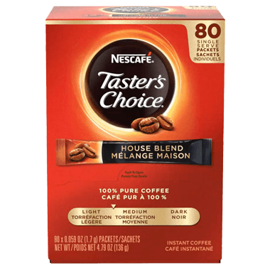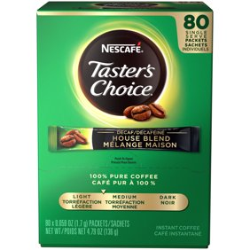

NESCAFÉ® COFFEE (BULK)  - Bulk coffee with over 550 servings per tin (55 pots)  - Convenient and easy to prepare  - Just scoop into cup or carafe and add water  - Long shelf life, Ambient storage  - No Waste | 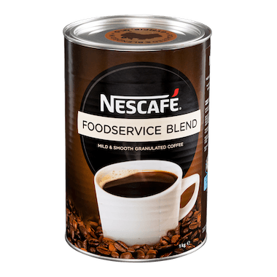

TEAVANA® TEA  - Individual filter bag, full leaf sachets in a variety of flavours  - Just add hot water and steep  - Infused with some of the finest teas and botanicals in the world | 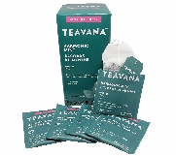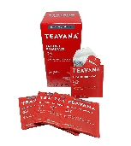

CARNATION® HOT CHOCOLATE 6x50x25g, 19g, 13g  - Individual Sachets - 300 servings in a case  - Rich & Creamy (19g & 25g) and Light (13g) versions  - Convenient and easy to prepare  - Just add hot water or milk, stir and enjoy  - Long shelf life, Ambient storage  - Kosher certified | 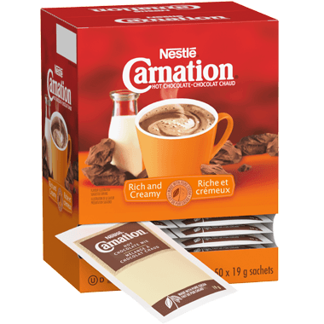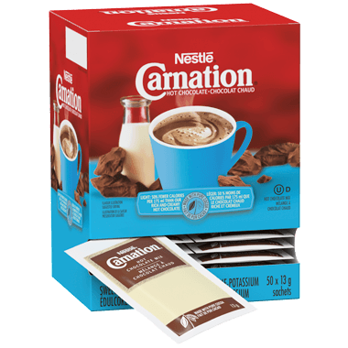

COFFEE EQUIPMENT NOT WORKING?
No Problem!

HOW TO HANDMIX BULK SOLUBLE COFFEE & SOLUBLE TEA  - Measure scoop of soluble coffee and add boiling water, stir  - 1.6g - 1.8 g coffee to 6oz. boiling water  - 17g - 19g coffee to 1 pot boiling water (64 oz.)  - 0.5 g of soluble tea to 6oz. boing water  - 5 g soluble tea to one pot boiling water (64 oz.) | 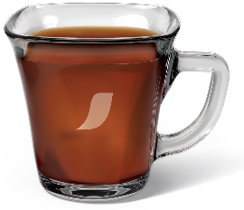

COFFEE COMPLEMENTS
No Refrigerated Storage Required

COFFEE-MATE®  - Original Powder - Available in Bulk Canister & Individual Sachets  - Liquid – Available in Individual Tubs and Pump Bottles  - Original/Double Double-mate, French Vanilla & Hazelnut  - Pump bottles are tamper-proof  - Lactose Free  - Kosher Certified  - No refrigeration required/Ambient storage  - Liquid is formulated with coconut oil  - No PHOs - Partially Hydrogenated Oils  - Long shelf life | 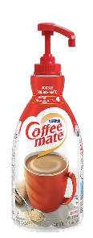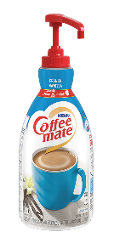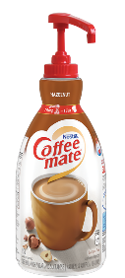  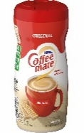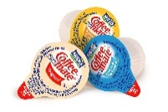

COLD BEVERAGES
No Dispensing Equipment Required

HANDMIX JUICES, JUICE DRINKS & BEVERAGES  - Available brands include NESTLÉ VITALITY®, SYSCO IMPERIAL® SYSCO RELIANCE®, GORDON CHOICE®  - Frozen and Ambient Formats  - Concentrated. Simply add water at stated mix ratio, mix & enjoy  - 12 x 30oz. cartons  - Mixing jugs available to order | 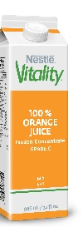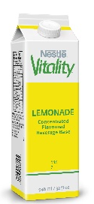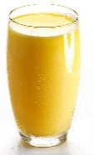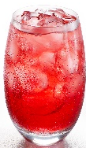

JUICE OR LIQUID COFFEE DISPENSER NOT WORKING?
No Problem!

HOW TO HANDMIX JUICE OR LIQUID COFFEE CONCENTRATE  - Thaw concentrate  - Remove cap on cartridge if dispensed  - Check packaging for the stated mix ratio (i.e. 6+1)  - Use a mixing jug with marked mix ratio lines (ask us)  - Or simply mix 1 part concentrate to 6 parts water (1 cup concentrate + 6 cups water)  - Follow the same with Liquid coffee at a mix ratio of 25+1  - Heat coffee and serve | 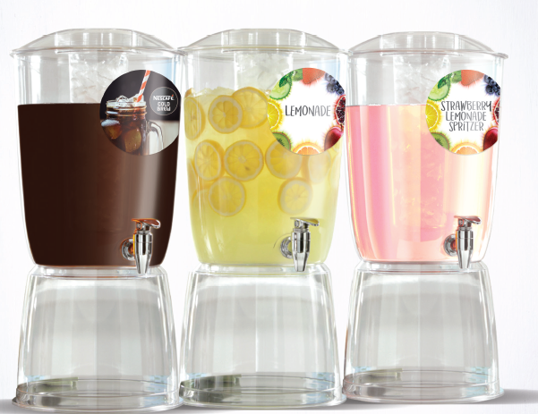
FOOD
Convenient, Quick and Easy to Prepare, No Special Training or Extra Labour Required

STOUFFER’S® ENTRÉES & SAUCES  - Full range of frozen complete entrées and sauces in half pan trays and 64oz. pouches that are easy to prepare  - On trend flavours and home-style comfort food classics like Stuffed Peppers, Lasagna, Chili, Demi-glace and Alfredo Sauces  - Simply heat and serve in a convection oven, standard oven, steamer, water bath, stovetop or microwave  - Stouffer’s Eat Better entrées are suitable for retherm systems, are low in fat and sodium, and meet protein requirements per 6oz. serving  - Consistent, high quality and food safe made in HACCP approved and federally inspected facilities | 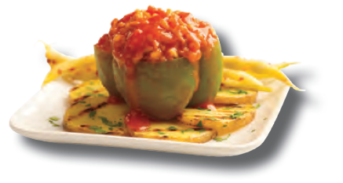  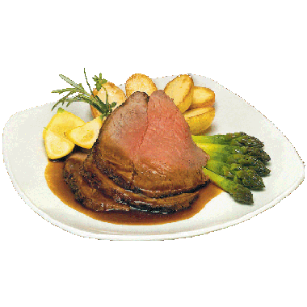

CARLA’S PASTA®  - Innovative and on-trend flavours, fillings and unique shapes  - Ravioli: Tutti Formaggi (Six Cheese), Braised Beef, Roasted Mushroom, North Atlantic Lobster, Sundried Tomato, Butternut Squash, Quattro Formaggi Florentine (Spinach & Cheese), Shrimp Scampi  - Others: Rainbow Tortellini, Beet & Goat Cheese Pacchetti, Lobster, Tutti Formaggi, Prosciutto & Fontina Sacchettini  - Individually Quick Frozen (IQF)  - High quality egg pasta with a higher filling to dough ratio  - Quick Preparation in multiple methods  - Boil for 3-5 minutes  - Steamer - spray pan and evenly spread (don’t layer)  - Strict quality control and food safety (HACCP and USDA)  - 18 months shelf life, 15 months for seafood varieties | 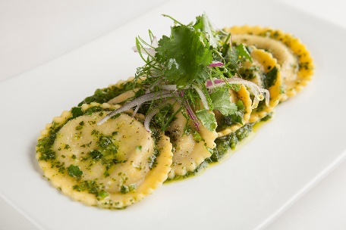  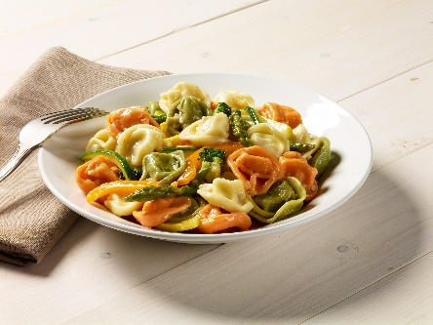

TRIO® GRAVIES & SAUCES  - Dry mix range of high quality, home-style tasting gravies & sauces  - Easy to Prepare in 3 Steps (TRIO) – Open, Pour & Stir  - Saves time and labour compared to scratch preparation  - Gravies - Brown, Beef, Turkey, Chicken, Au Jus  - Brown Gravy is Vegetarian  - Sauces - Cheese, Hollandaise, Nacho Cheese  - Long shelf life, Ambient Storage, Bag Re-sealing Strip | 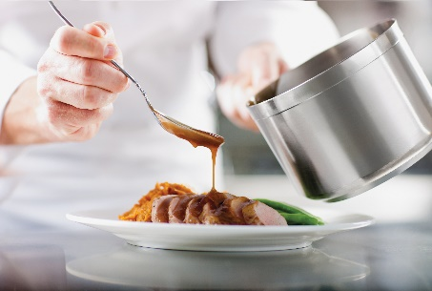

GRAB & GO AND SWEET TREATS
Keep them going and keep them smiling!

STOUFFER’S® SINGLE SERVE MEALS  - Full range of wholesome, healthy and nutritious meals/snacks on the go.  - Frozen options that are easy to prepare, heat and enjoy  - Recognized brands under the STOUFFER’S umbrella  - STOUFFER’S  - STOUFFER’S LEAN CUISINE  - STOUFFER’S BISTRO  - STOUFFER’S FIT BOWLS  - STOUFFER’S MARKETPLACE CUISINE  - Consistent, high quality and food safe made in HACCP approved and federally inspected facilities | 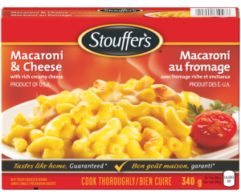  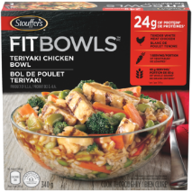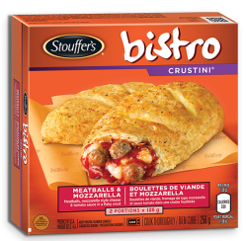

NESTLÉ® CONFECTIONARY BARS
- A sweet indulgence and a variety of bars to choose from
- Our Core 4 are the top Nestlé sellers that appeal to more consumers
  - KIT KAT® - #1 selling bar in Canada
  - AERO®
  - COFFEE CRISP®
  - SMARTIES®
- 55% prefer sweet snacks to 45% that prefer salty snacks
- Chocolate is always enjoyed by all ages

NESTLÉ® ICE CREAM  - Canada’s #1 selling Ice Cream Novelties and the leader in innovation  - National Top Selling Brands include:  - Häagen Dazs  - Drumstick  - Nestlé (Confectionary)  - Parlour  - Real Dairy  - Maynards #1 candy brand - Swedish Berries, Fuzzy Peach  - Guaranteed a smile when Nestlé Ice Cream is available | 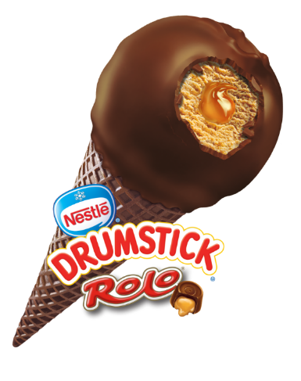

For more information on our exciting portfolio of products, please contact Cyndi Carey at
(289-439-4164), or email at Cyndi.Carey@ca.nestle.com

To place an order, please contact your respective distributor of choice. Please note that not all products are available at all distribution warehouses.

Thank you for your continued support.

Attachment: Nestlé Professional Be Prepared Product List 2020.xls

